**Aim:** To make an activity Diagram for University Database.

**Diagram:**

Activity Diagram for University Database

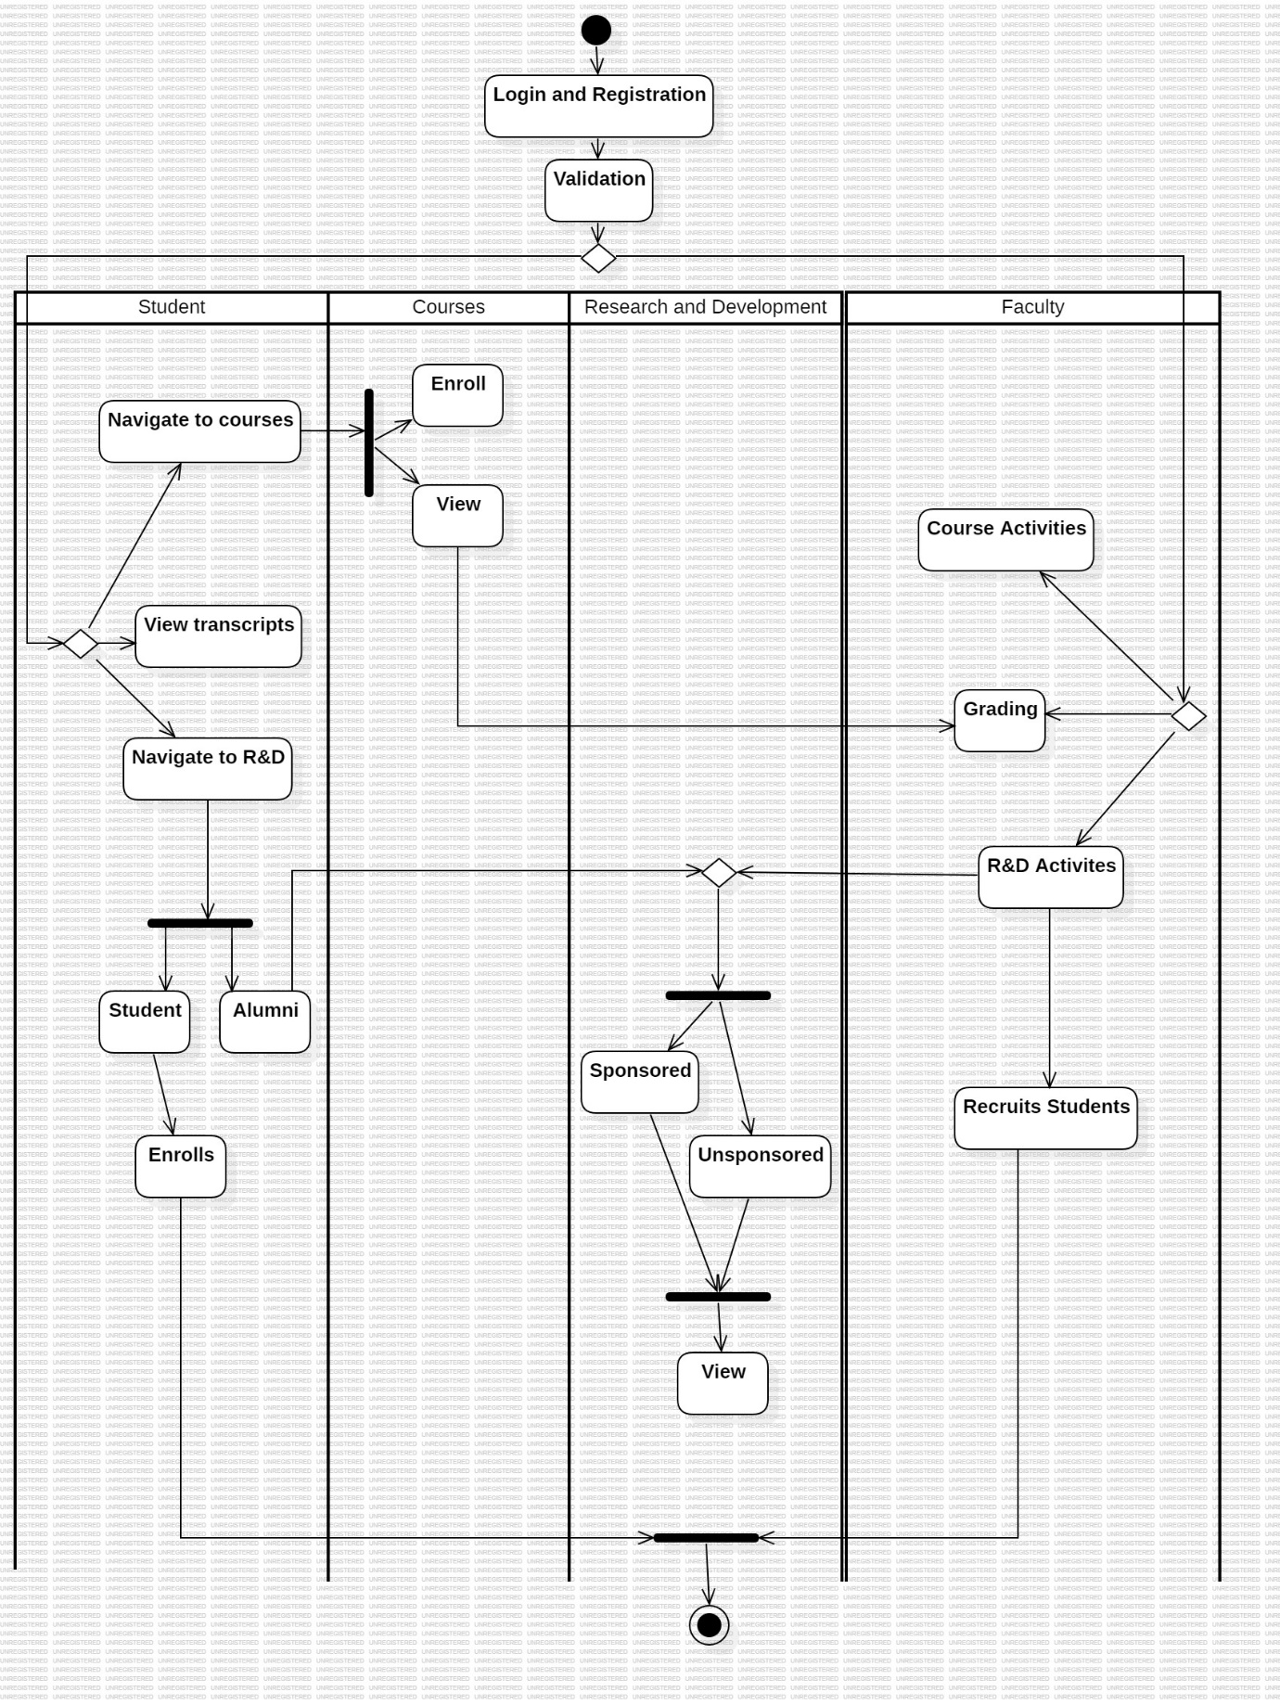

**Explanation:**

In the above activity diagram, there a 4 swim lanes student, courses, Research and Development and Faculty. The diagram represents the flow and organisation of the University database system.

The supposed system will identify the type of user and then present it relevant options accordingly.

For example, a student will be presented the options to enroll into courses or to view courses they’re enrolled into. Also they can view transcripts, etc.

**Risk Management for the above scenario:**

| **Risk ID** | **Risk Description** | **Impact** | **Likelihood** | **Mitigation Strategy** |
| --- | --- | --- | --- | --- |
| R1 | Breach of sensitive student data | High | Low | Encrypt data, access controls, 2FA |
| R2 | Inaccurate student transcripts | High | Medium | Input validation, audit trails |
| R3 | Course registration failures | Medium | High | Run test cases to identify issues. |
| R4 | Incorrect course information | Low | Medium | Validation checks, change approvals |
| R5 | Research data loss | Medium | Low | Backups, redundant storage |
| R6 | Poor system performance | Medium | Medium | Tuning, capacity planning |
| R7 | Grant and Research compliance errors | High | Low | Automated controls, audit trailing |

**Observation:**

The activity diagram will help in visualizing the flow of the system via swimlanes and control flow arrows. The risk management analysis helps us in identifying risk and their probability. It also helps in developing mitigation strategy in case if the risk occurs.